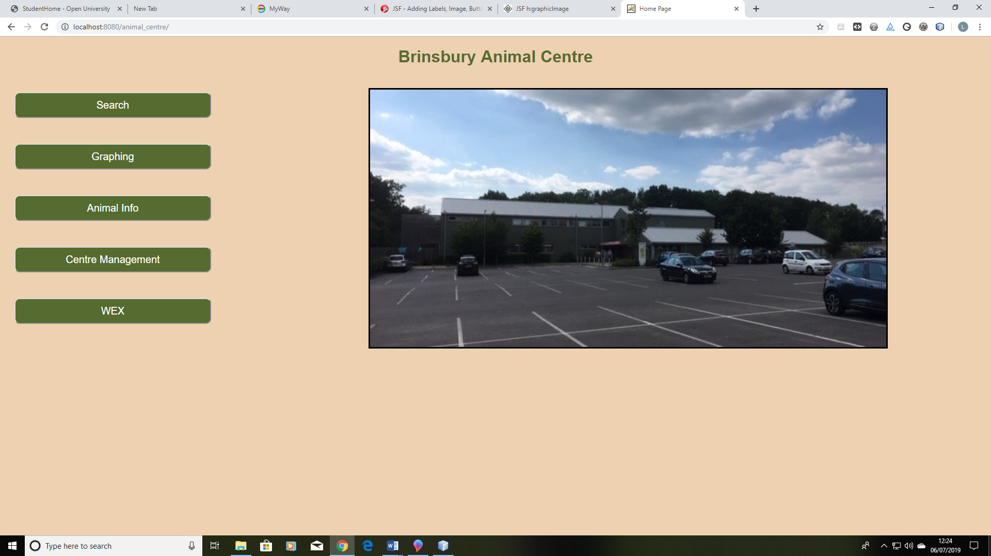

Image 1. The home page of the web application

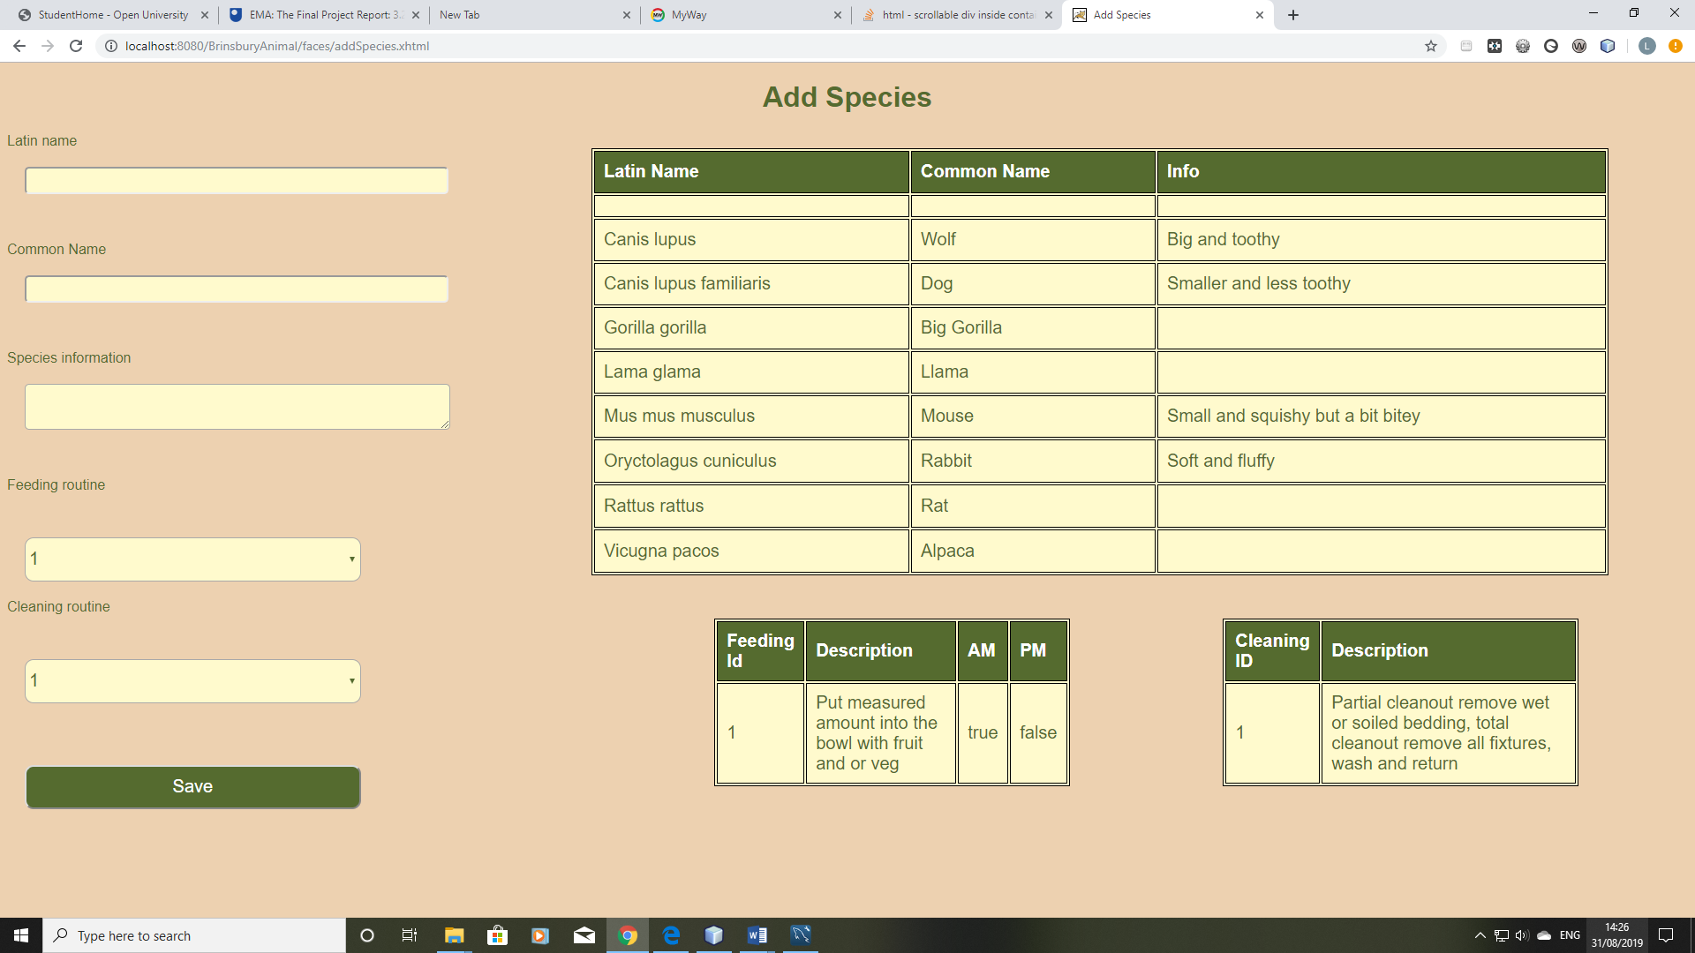

Image 2. The add species UI

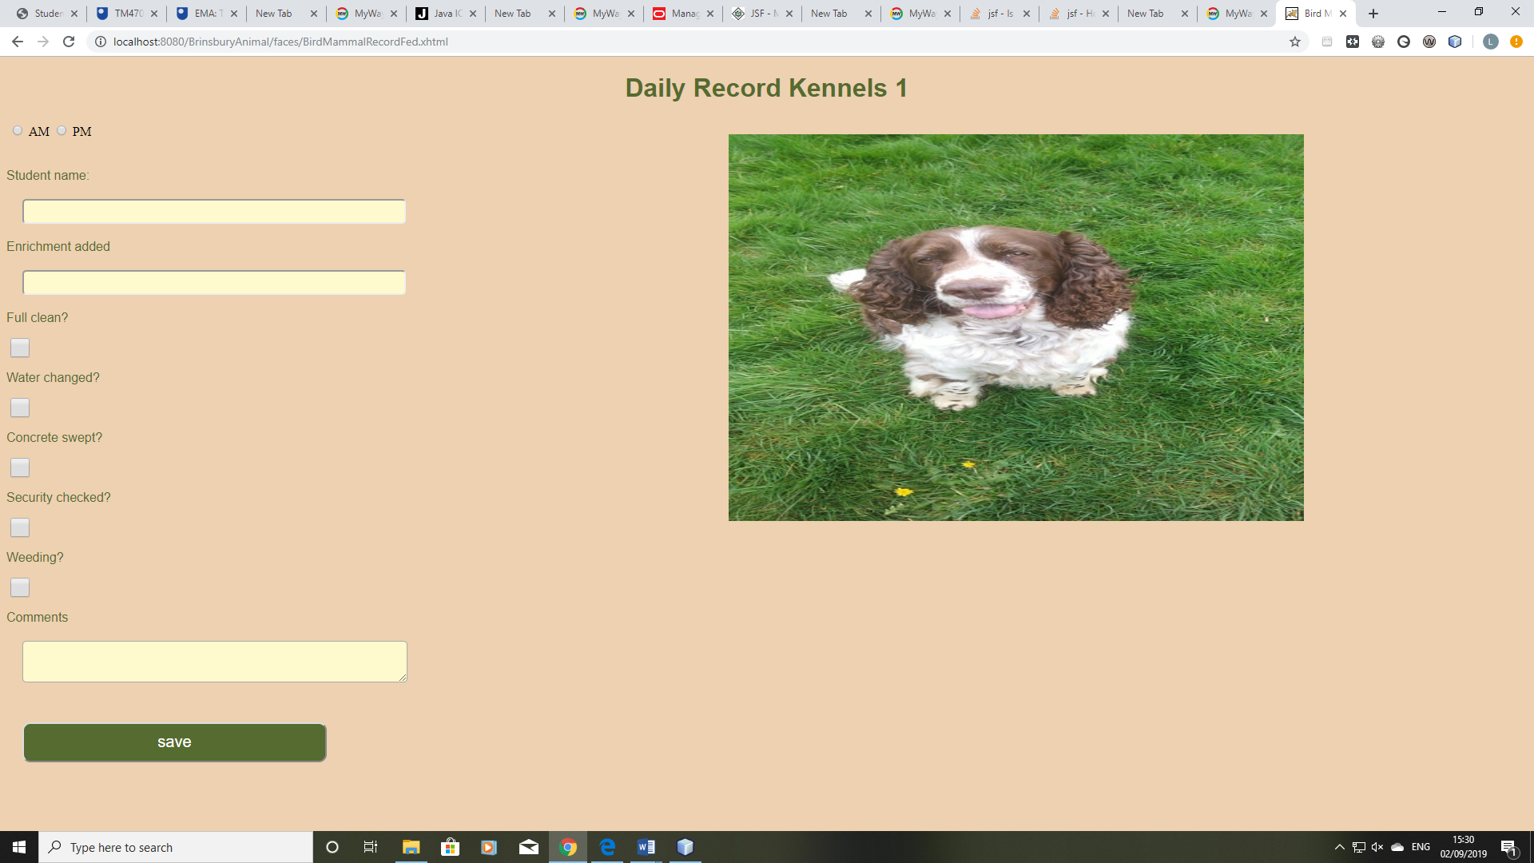

Image 3. The user interface for entering daily record information

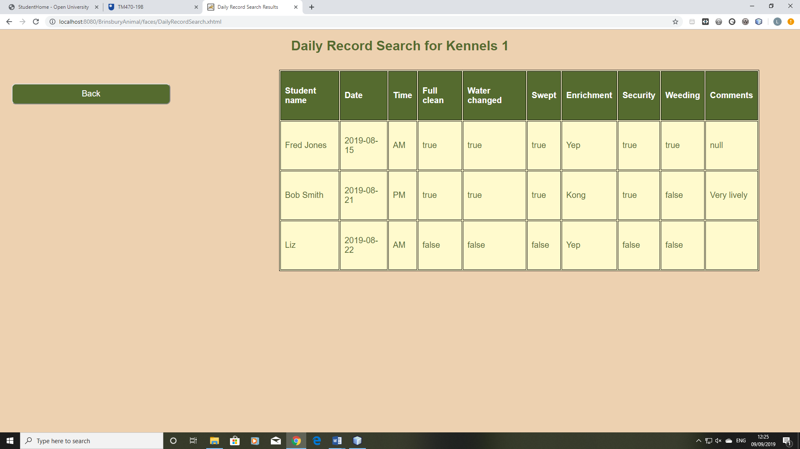

Image 4. Table showing search results of records for a selected accommodation